Task 1:- Create a Digital Literacy Awareness Infographisic
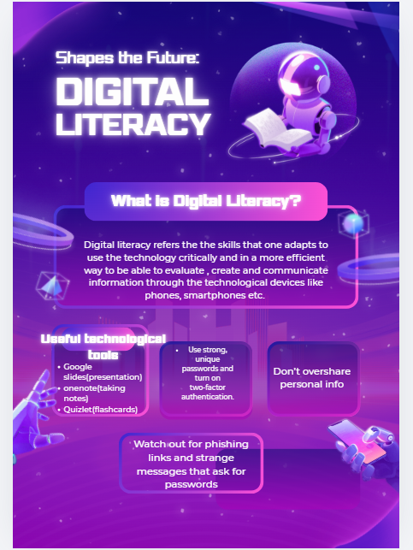
My sample canva style slide.

Report:-
I used Canva as my tool to design my infographic style on digital safety and skills . Canva is a helping tools that has become useful in the recent years. The slide covers three main topics starting by introducing with what is digital literacy .In the slide , I added the useful digital tools by mentioning tools like google workspace(Docs, Sheets and slides) and note taking apps etc.
The third part focuses on safe internet practices, including strong passwords, avoiding oversharing personal information, recognizing phishing links, and knowing how to report suspicious content.
Canva helps us by giving us sample template so that we can design it more efficiently . It helps us enhance our posters, presentations so that it is more appealing to the viewers eyes and I able to interpret more.
One interesting challenge was balancing clarity with visual clutter; I had to limit text and icons so that the slide remained easy to read at a glance. I kept colours consistent ,so viewers could quickly scan and understand each section. Overall, making this infographic helped me think more intentionally about how to translate abstract digital concepts into simple, structured visuals.

